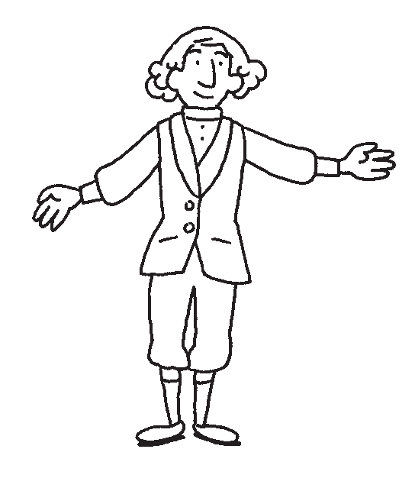
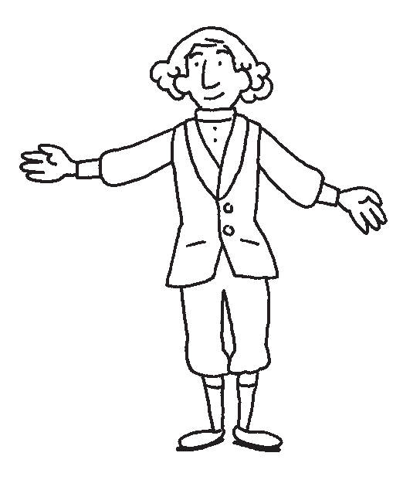
fun with composers

Symphony no. 40
music: w.a. mozart; music map: d. ziolkoski

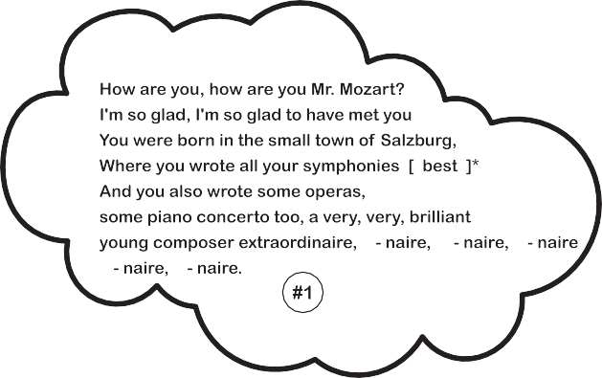

Form: 1, 2, 3, 4, 5, 6

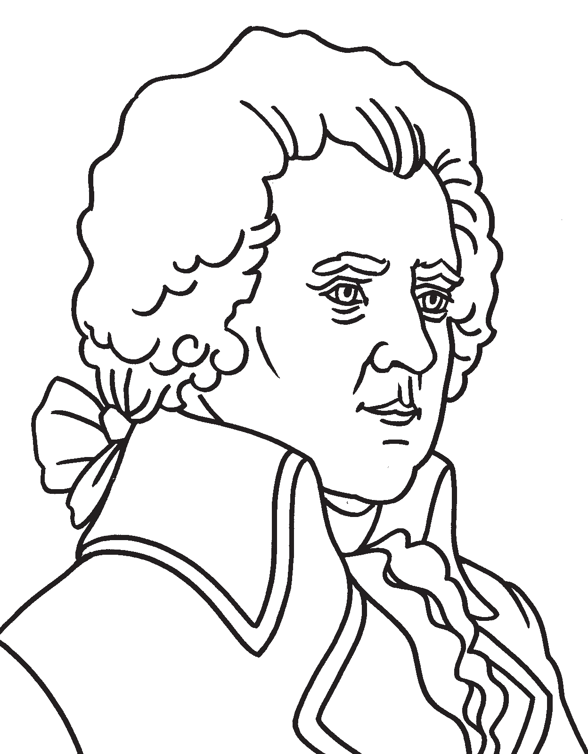

Wolfgang Amadeus Mozart
(1756-1791)

Wolfgang Amadeus Mozart was born in Salzburg, Austria, in 1756. The Mozart house was a very musical one. Wolfgang’s father, Leopold Mozart, was a composer and a violinist.
When Wolfgang’s sister, Nannerl, was seven, she began lessons on the clavier (a small keyboard). Wolfgang’s father let him listen to her lessons while he played, but always told him that he was too little to take lessons himself.
One day, however, Mozart played one of his sister’s pieces without ever having taken a single lesson! By the age of four he could play anything his sister played, and also compose music of his own. Wolfgang also became an excellent violinist. Without having taken even one lesson, he picked up the violin and played it like an expert. He was an amazing little boy.
Wolfgang’s father planned a tour with both his children. Wolfgang and his sister performed together, charming everyone in the land. They were even invited to play for the king and queen! Mozart was especially talented and charming. He had a great sense of humour, and loved making people laugh!
One day, while giving a concert for the king, Mozart played so well that the king thought he was tricking him. The king didn’t believe it was possible for such a young child to play so well. So, right before Mozart was about to play the clavier, the king pulled out a black cloth and placed it over the keyboard so that Mozart couldn’t see the keys. Then he asked Mozart to play.
Mozart just laughed, since it didn’t make any difference to him whether the keys were covered or not. He started to play, and he played his piece perfectly, without missing a note! The king couldn’t believe it!
When Mozart grew older, people didn’t seem to find him so cute anymore. They got used to him composing such amazing music, so many of them stopped going to his concerts, and he became quite poor.
Mozart had great parties and bought many beautiful clothes, but he often forgot to save for important things! When he was just thirty-five years old, Mozart got very sick and died. There was no money for a funeral or a cross for his grave, but many years later the people of Vienna built a great monument in his memory.
Today, Mozart is still one of the greatest musicians ever to have lived! People from all over the world listen to and love his music.

